参考：
https://stackoverflow.com/questions/43196636/how-to-concatenate-two-layers-in-keras
https://nbviewer.jupyter.org/github/anhhh11/DeepLearning/blob/master/Concanate_two_layer_keras.ipynb
https://www.programcreek.com/python/example/89660/keras.layers.concatenate

环境：
env:Linux ubuntu 4.4.0-31-generic x86_64 GNU;python 2.7;tensorflow1.10.1;Keras2.2.4
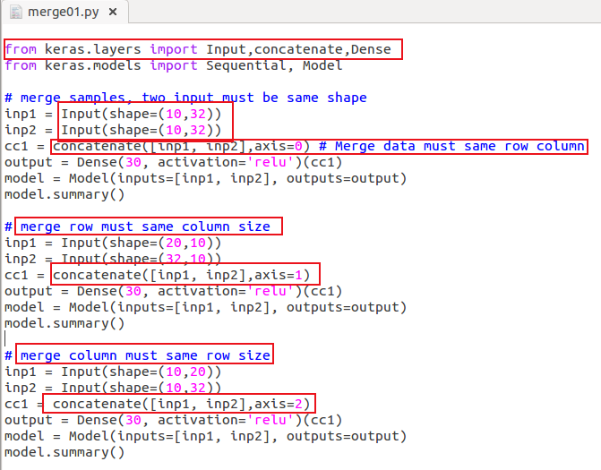
sun@ubuntu:~/sun/merge_keras$ python merge01.py
